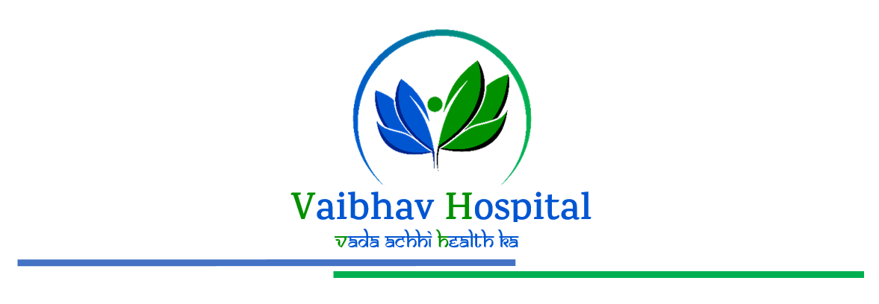

**FINAL BILL**

|  |  |  |  |  |
| --- | --- | --- | --- | --- |
| Sr. No. | Details | Rate | Quantity | Net Amount |
| 1 | Admission charge | 600 | 1 | 600 |
| 2 | Admission charge | 600 | 1 | 600 |
| 3 | Admission charge | 600 | 1 | 600 |
| 4 | Admission charge | 600 | 1 | 600 |
|  | **Total** |  |  | **2400** |